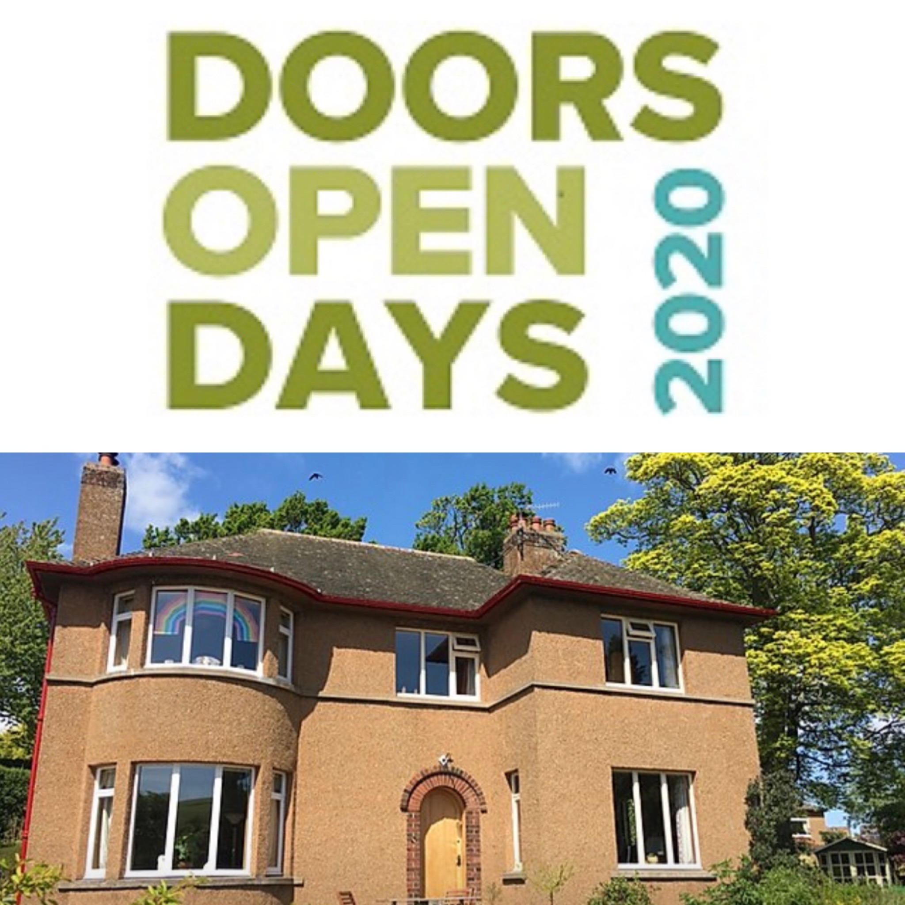

The Forties House, Cupar

Virtual Tours Proposal

#DIGIDOORSOPEN #DODSCO

STA Project No. | IT-211
Published Date | 12/08/2020
Version | v0.2
Author | Roddy McRae, Scottish Tech Army Volunteer
Clients | Damon Wilkinson, Forties House Owner and Nicola Godsall, Doors Open Day – The Scottish Civic Trust

Version Change History
Version | Date | Author | Review | Comments
0.1 | 12/08/2020 | Roddy McRae | Damon Wilkinson | First draft
0.2 | 03/09/2020 | Roddy McRae | Damon Wilkinson, Nicola Godsall ( Scottish Civic Trust) | Incorporated Damon’s initial feedback and drafted “Case Study section 5.0”, updated all tool tables

Contents

Introduction

  - Purpose of Document

Overview

2.1 Background
2.2 Goals and Objectives
2.3 Outline Approach

Requirements

3.1 Virtual Event Content Creation
3.2 Video sharing
3.3 Booking
3.4 Hosting – Videoconferencing

Tool Options

  - Introduction
  - Capture
  - Edit
  - Share
  - Book
  - Host

The Forties House Approach ( Case Study )

  - Tool Review and Selection
  - Tool Choice
  - Marketing and Publicity

Conclusion

Appendix 1 Pre-Event Testing Results

Introduction

1.1 Purpose of Document

This document describes the project background, goals and objectives for managing and hosting an event at the Forties House opening virtually for Doors Open Day 2020 over the weekend of 5-6th September.

It will review the process of event production looking at various digital tools options to help the owner host and manage a virtual delivery for remote visitors. This will then allow for the selection and a final choice of digital tools for the successful delivery of virtual tours/question and answers sessions for Doors Open Day 2020 at the Forties House.

The document is also intended to be used as a blueprint for other “Doors Open Day” partners who may wish to consider managing and hosting virtual tours for their own properties in the light of COVID-19 restrictions, that may otherwise prevent their participation. It may hopefully provide help and guidance to property owners to run and manage their own events in later months outwith September’s Doors Open Day.

2.0 Overview

2.1 Background

The Forties House in Cupar was built in 1936 by Frances Grove Peddie, Assistant Public Assistance Officer, to provide a comfortable, modern home for his family. It survived the decades with limited modernisation, which has been reversed by the current owners.
​
The interior is entirely furnished with authentic pieces from the 1930s and 1940s. This includes all technology, appliances and household wares that were available at the time and continue in daily use. See https://www.fortieshouse.co.uk for further detail.

Owner Damon Wilkinson and his partner have been participants in Doors Open Day https://www.doorsopendays.org.uk for 5 years. The size of the property and current COVID-19 restrictions will prevent in-person tours this year and alternative virtual options are under consideration.

In previous years, groups of six people were catered for over a weekend. These were split into 8 x 1 hour tours with a capacity of 96 visitors. Often visitor bookings exceeded available places and were manually managed by email with Damon updating a spreadsheet.

The property has its own website mentioned earlier and a Facebook page https://www.facebook.com/fortieshouse/

2.2 Goals and Objectives

This project has been created to examine options for the digital delivery of tours of The Forties House for online audiences offering the potential benefits of continued participation in Doors Open Days while allowing larger group tours to attend compared to the normal physical limits of the actual property during previous years.

In addition to this, we hope that this project will offer a potential blueprint for other property owners seeking to produce their own virtual Doors Open Days events.

2.3 Outline Approach

Damon plans to create a number of pre-recorded mini tours of the various rooms in the property for people to view in advance, potentially on YouTube. He may create some additional themed videos on topics such as leisure, cooking and the vintage home to compliment the event.

He has requested that he would like to run live interactive pre-booked virtual question and answer sessions for remote visitors. Initial thoughts are to theme the Q&A sessions, for instance, by having an hour in each of the main rooms: sitting room, bathroom, kitchen, dining room, bedroom, and study. Some props to illustrate specific items could be on hand to stimulate conversations.

During our initial discussions we have tried to consider the personas of the virtual audience. Our initial thoughts created three types, general public (locals), interior designers and creatives and nostalgic older people. Content creation, online accessibility and ease of use of the various tools described later was a factor in our tool selection.

3.0 Requirements

3.1 Virtual Event Content Creation Stages

I have broken down the requirements into a series of steps that are involved in creating such a virtual event detailed in Table 1 below. The moving images need to be captured and then edited as required to create pre-recorded content. When ready, they will be uploaded to the selected video sharing platform ready for use. Any later recordings during Door Open Day may be uploaded as required.

The organiser then has a choice of manual or digital booking systems to manage their event. This will depend on a number of factors such as the numbers anticipated, frequency of tours and capacity limits of the tools chosen to manage their event. There is no requirement to market and publicise the event as this will be managed through the Scottish Civic Trust website and email database.

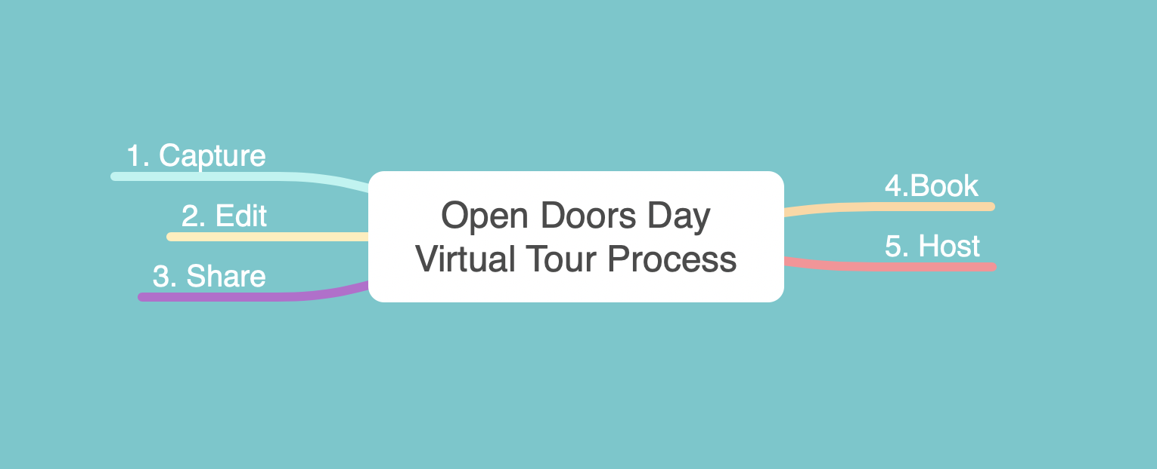

Table 1

4.0 Tool Options

4.1 Introduction

There are a multitude of online tool options covering each of the five steps of capture, edit, share, book and host as outlined in Table 1. Some may be familiar and others less so. Personal preferences may be helpful in reducing the amount of knowledge and training required. To reduce complexity and help with tool selection Table 2 shows the tools and software under consideration.

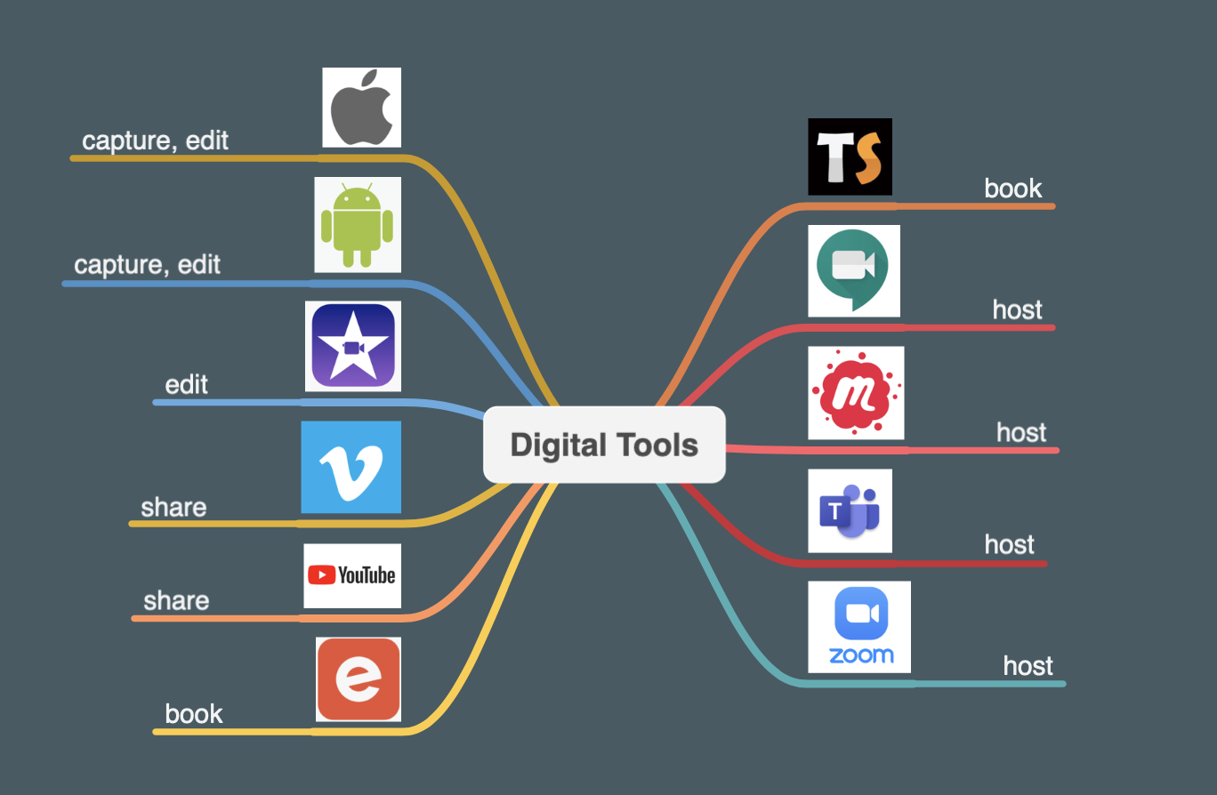

Table 2

Table 2 shows a number of potential apps in no particular order that can be utilised to support the creation and production of a virtual property tour. More details can be found in Tables 3 - 7 on page 9 to page 13. These include links to provide further details on each tool as required.

4.2 Capture

Smartphones, tablets, digital cameras and video cameras all offer a wide choice of options to capture video and stills images, to showcase your property. There is a wealth of guidance online that you can reference related to your personal equipment. Practice in my own experience is the best way forward here or if your time is limited, find a friend who is competent in video and collaborate in producing and editing your content with the various apps that are freely available.

4.3 Edit

The smartphone operating system (Apple or Android) that you use determines the apps that I have recommended. There are literally hundreds of options that I am unable to fully review here. This guide is not intended to be exhaustive due to time constraints and for simplicity.

We have chosen tools based primarily on Damon’s feedback and my past experience of leading a photography festival and professional experience as a former Picture Editor. If you find better apps and wish to share your knowledge and feedback it would be very welcome. Please email dod@scottishcivictrust.org.uk .

4.4 Share

Two of the most commonly used video sharing platforms are included. Namely, YouTube
( www.youtube.com ) which the best known by the general public. Another, great option that excludes advertising is the professional platform Vimeo ( www.vimeo.com ).

Both offer free and chargeable versions depending on the functionality that you are seeking. The choice is yours.

4.5 Book

One of the most popular event management tools is Eventbrite ( www.eventbrite.com) and it is free for users ticketing free events which is perfect for Doors Open Day properties. I have included two additional options, namely, MeetUp ( https://www.meetup.com ) and Ticketsource ( https://www.ticketsource.co.uk/event-booking-system ). See Table 5 (Book) for further detail on costs and comments.

4.6 Host

Video Conferencing was previously largely the preserve of commercial users, however, COVID-19 has significantly accelerated this market for personal and business users. The best known newcomer is Zoom ( www.zoom.us ) , while Google ( https://meet.google.com ) and Facebook ( https://www.facebook.com/formedia/solutions/facebook-live ) have reacted with upgraded tools and the choice has expanded. Microsoft Teams is another popular web conferencing application becoming widely adopted across the private and public sectors
( https://www.microsoft.com/en-gb/microsoft-365/microsoft-teams/group-chat-software ). Facebook’s sister company, Instagram also allows live streamed events that have proved popular with the public during lockdown. It may play well if you have a popular Instagram account associated with your property?

Virtual Property Tours – Tool Options

1. Capture
Tool | Type | Function | Notes
Mobile Phone | Android or Apple | Photography, Videography | Stills images, video footage and 360 degree video and editing apps
Tablet | Android or Apple | Photography, Videography | Stills images and video footage and editing apps
Stills or Video Cameras | DLSR, Compact, Camcorder | Photography, Videography | Stills images, video footage and 360 degree

Table 3

2. Edit
Software | URL | Function | Cost | Notes
iMovie | https://www.apple.com/uk/imovie/ | Video Editing | Free Apple app | All Apple OS. Clips is another good Apple video app
Adobe Premiere Rush | https://www.adobe.com/uk/products/premiere-rush.html?promoid=12B9DXYJ&mv=other | Video Editing | Free Android app | Android
Adobe Premiere Elements | https://www.adobe.com/uk/products/premiere-elements.html | Video Editing | £86.56 | Premiere Elements and Premiere Pro
Adobe Premiere Pro | https://www.adobe.com/uk/products/premiere.html | Video Editing | £19.97 per month | See Adobe Cloud subscription plans

Table 4

3. Share
Software | URL | Function | Cost | Notes
YouTube | https://www.youtube.com/?gl=GB | Online Video Sharing Platform | Free | A channel needs to be created via a Google account
YouTube | https://www.youtube.com/premium | Online Video Sharing Platform | 11.99 per month | See above
Vimeo | https://vimeo.com | Online Video Sharing Platform | Free | Note: there is an upload limit

Table 5

4. Book
Software | URL | Function | Cost | Notes
Eventbrite | https://www.eventbrite.co.uk/ | Digital Booking | Free for Free Tickets | Most well known
MeetUp | https://www.meetup.com | Digital Booking | Monthly Subscription | Very popular business and personal group meeting tool
TicketSource | https://www.ticketsource.co.uk/event-booking-system | Digital Booking | Free for Free Tickets | UK based event management software

Table 6

5. Host
Software | URL | Function | Cost | Notes
Google Meet | https://meet.google.com | Meeting Hosting | Free | Formerly known as Google Hangouts
Facebook Live | https://www.facebook.com/facebookmedia/solutions/facebook-live | Meeting Hosting | Free | Possible alternative to those more familiar with Facebook. Sister business Instagram offers Live Video
Zoom | https://zoom.us | Meeting Hosting | Free | Provides good functionality for
Zoom Professional | https://zoom.us |  | per month | Allows greater participation and fully featured
Microsoft Teams | https://www.microsoft.com/en-gb/microsoft-365/microsoft-teams/group-chat-software | Meeting Hosting | Need Microsoft 365 Account | Primarily a business service. Being constantly improved.

Table 7

5.0 The Forties House Approach ( Case Study )

5.1 Tool Review and Selection

The tool options were reviewed with Damon and the final selection was made to produce the Forties House Doors Open Day virtual tour.

Damon and I ran through the five step process outlined in Table 1 to map out the tools required. Since our initial meeting Damon had produced, edited and uploaded some additional short videos looking at specific rooms in the property and some focusing on cooking and leisure to complement the weekend tours. These will be made public at the Doors Open Day weekend via a link https://www.fortieshouse.co.uk/visitfortieshouse

The tool selection was relatively straightforward as Damon already owned an iPad Air 2 and iPhone 6s and was familiar with YouTube. With Apple devices you can edit video in the fully featured iMovie or using the Clips app on the iPhone or iPad.

For video sharing a channel needs to be created to upload videos to YouTube via a Google Account. Damon was already familiar with YouTube and had some experience of using Apple’s iPad for filming and editing the short videos that he had produced.

Given the numbers anticipated and Zoom limits it was decided not to use any booking tools
for these events. If you wish to engage an audience in the future, a booking system would allow permission based marketing for the property. The Forties house Facebook page does provide a measure on interest via Likes and interest can be gauged for specific Facebook events.

Finally, hosting options were considered and Damon chose to use Zoom

5.2 Tool Choice

Table 8 below summarises the tools selected for the virtual events on September 5/6th 2020.

 | Forties House - Event Production Tools
 | Tool / Software | Function | Cost | Notes
Capture | iPad Air 2 / iPhone 6S | Image and Sound Capture | n/a | Existing equipment
Edit | iMovie | Editing Software | Free | Apple app for iPad
Share | YouTube | Video Sharing Platform | Free | Mobile, tablet, desktop versions
Book | n/a | n/a | n/a | n/a
Host | Zoom | Meeting Hosting | Free | Mobile, tablet, desktop versions

Table 8

5.3 Marketing and Publicity

Publicity and marketing for the virtual events will be managed through the Scottish Civic Trust’s website https://www.doorsopendays.org.uk with a “find a building” search tool on their homepage.

The properties are searchable by region, in this case “Fife Doors Open Days East” or by the open weekend.

https://www.doorsopendays.org.uk/places/fife-doors-open-days-east/the-1940s-house/

The Forties House homepage has been updated to direct visitors to the links to view YouTube and Zoom meetings – see grab below

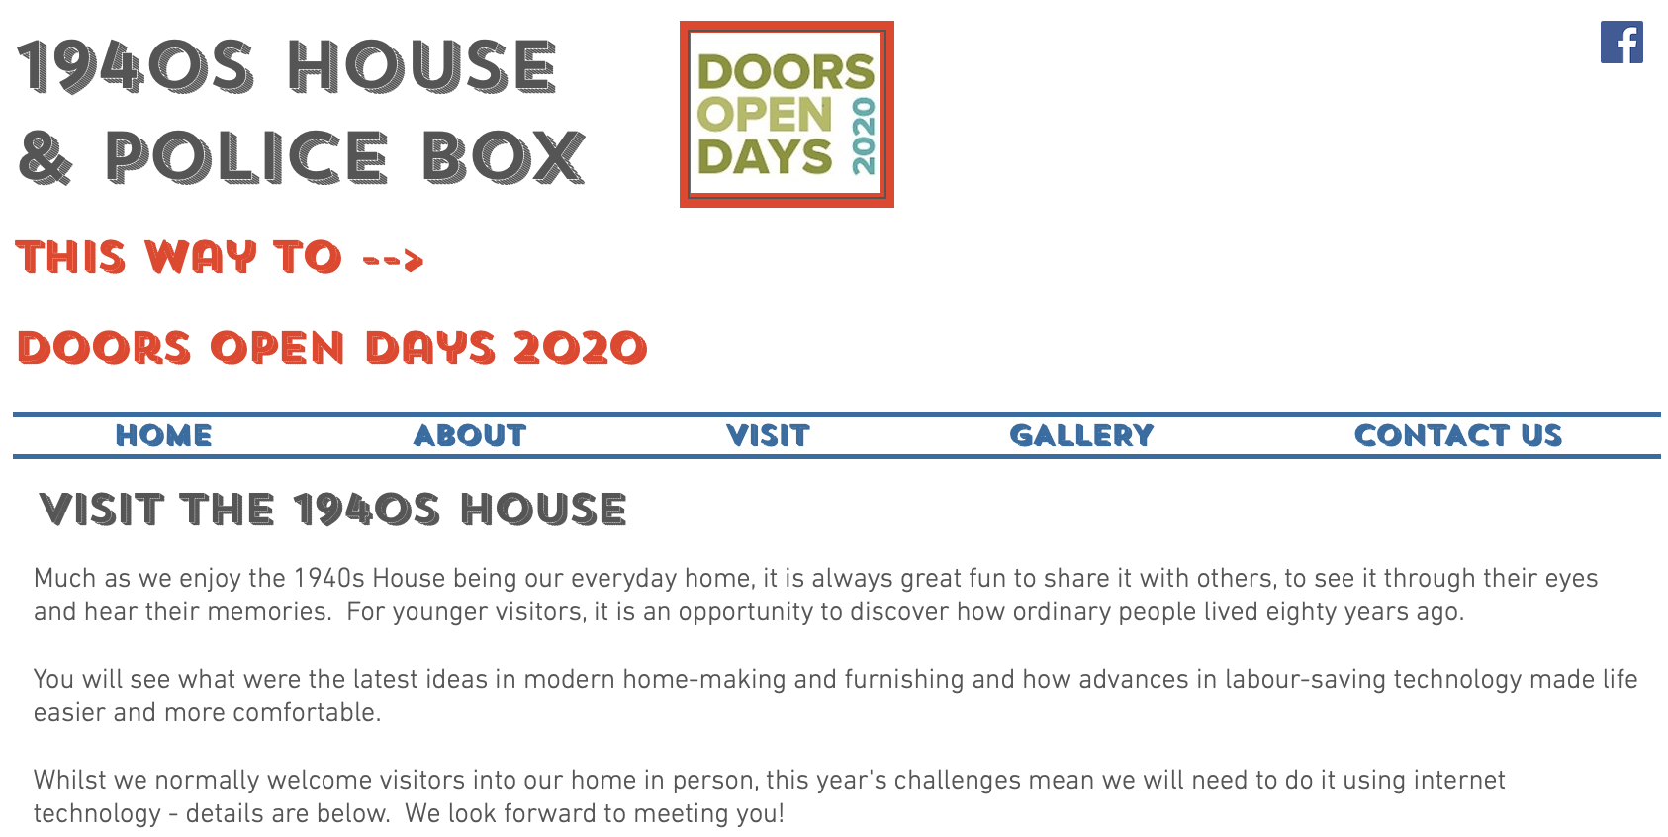

6.0 Conclusion

This is a completely new virtual tour event planning and hosting experience for everyone involved due to restrictions caused by the Covid virus.

Internet accessibility was a consideration, however, it will be determined by the specific devices, tools (e.g. apps) and web browsers used by individuals. It may be something that requires additional thought and review in the future. The Scottish Civic Trust may conduct further work on a future STA project as discussed with Nicola Godsal.

From the outset simplicity, familiarity, ease of use and free tools were key elements in the selection process for Damon and his virtual Doors Open Day event at Forties House. The end user experience was tested in the run up to the weekend. See Appendix 1 for tests made by Damon. Post event feedback could prove valuable in designing and running future virtual events. Damon has already confirmed that he is happy to participate in a post event review to provide lessons learned.

Appendix 1 Test Checklist

Test | Description | Result
Navigating to session | Was it easy to for attendees find the link to the session? Shared via the Forties House website. | Success
Downloading / launching | Was it easy for attendees to download / launch Zoom?  Out of the 9 participants, only 1 was new to Zoom and his access was smooth. | Success
Wireless reception | Visit extremities of property to identify areas where the wireless reception cannot support the video call. An upstairs room and the back hall on ground floor had signal drop. A signal booster will be purchased and trialled prior to the event | Success
Video quality and lighting | Is the picture sufficient for attendees to see close up and wider views? (Particularly given Zoom's advice that video may be degraded for sessions with over three attendees.) Overall the experience worked with some picture freezing, but no loss of sound. The router location appeared to be the cause of problems with drop off caused by being too far from router ‘s range. Note: the test was conducted in an evening with the light level lower than daytime. A further lighting check has been recommended and all interior lights will be used to improve viewing quality over the DOD weekend. | Largely successful
Sound quality | Is the sound sufficient for attendees to understand what is being said? Damon’s voice was clear and his presentation was excellent. | Success
Movement | What is the optimal speed for moving from place to place? All agreed that slower and more considered movement was required. The tendency was to go too fast. The iPad camera’s focusing could lag slightly as well. Damon was made aware of holding the camera looking downwards too much and corrected this. | Success
Muting | Mute one / all attendees if there is background audio interference. This was tested during the walkthrough | Success
Removing to waiting room | Remove an attendee that is causing difficulty. | Success
Sharing additional resource | Check whether it is possible to show a video / photograph. Damon was able to share his desktop. Note: this was a real first test and more practice will help with control familiarisation and better interaction. | Success

